**Market Forecasting Using ARIMA and LSTM Model for American Airline Group Inc. (AAL)**

**Ziqi Dai:** zd2301

**Mingxian Ling:** ml4796

**Han Wang:** hw2900

**All contributions are equally distributed**

**GR 5221 Time Series Analysis**

**Instructor: Dr. Gabriel Young**

**4 May. 2023**

1. **Introduction**

The main focus in this project is market forecasting using Autoregressive Integrated Moving Average (ARIMA) model and Long Short Term Memory (LSTM) model for American Airline Group Inc. (AAL). This project would like to use previous stock close price to forecast future stock price of AAL company by using ARIMA and LSTM models, and then compare which model could make better prediction for AAL in stock market.

The motivation for our group to choose this topic is simple. Due to the high risk involved, it is difficult for most people to make investment decisions based on the common trends of the stock market in society. However, by studying seasonal variations and stable flows in any index, both existing and new investors can gain a better understanding and make informed decisions to invest in the stock market *(Pathak, 2022).* Hence, this project not only can forecast the movement in the stock market depending on time, but also can provide an efficient guide for investors to minimize risks and maximize profits.

Compared to our original proposal, the final project makes some changes about variable selected. We decide to use close price rather than volume since the closing price is the useful indicators for investors evaluate the fluctuations in stock prices over a period of time. Hence, in this project, we pay attention to use close price of AAL company over time and make prediction by using different time series model.

We structured this project in the following section. Section 1 talks about purpose and interests for this project. Section 2 shows the exploratory data analysis. Section 3 introduces the time series models and modeling process. Section 4 describes the model validation. Section 5 provides the forecasting by using different models. Finally, Section 6 shows the conclusion with some possible extension in the future.

1. **Exploratory Data Analysis**
   1. *Dataset Sources*

Our group decide to use the dataset (S&P 500 stock data) shown on Kaggle. This dataset offers historical prices (last 5 years) for all companies shown on the S&P 500 index currently *(Nugent, 2018).* However, our project only chooses American Airline Group Inc. (AAL company) historical close price data for past 5 years to do future times series forecasting so that we can make better understanding in the stock market.

* 1. *Brief Summary of the Original Dataset*

This dataset contains 7 variables. It includes the date, the stock’s ticker name (Name), number of shares traded (volume), the highest price (high) and the lowest price (low) reached in the day, and the price of the stock at market open (open) and at market close (close).

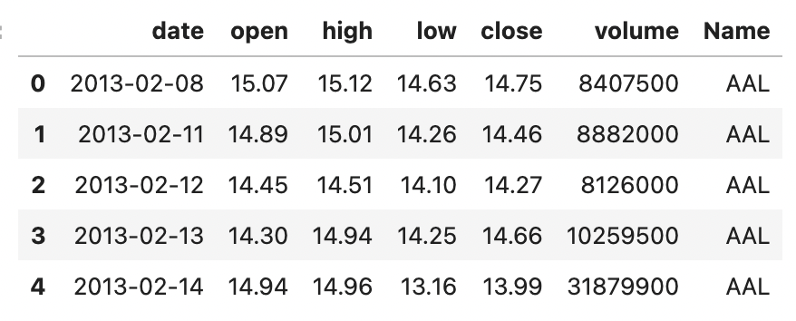

*Table 1: The Original Dataset*

* 1. *Data Selection*

Since we know that the close price of the stock is really vital, this project focus on the close price of AAL company over date. The independent variable (X) is date, and the dependent variable (Y) is close price of AAL company. There is no missing data in AAL company for past 5 years, and we only need to choose the data we need and then transfer the ‘date’ to datetime structure. Then, the data frame shows below:

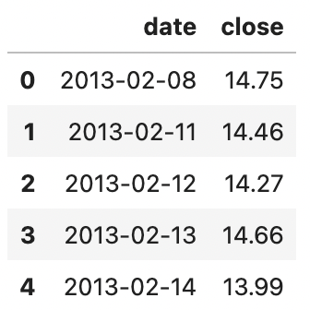 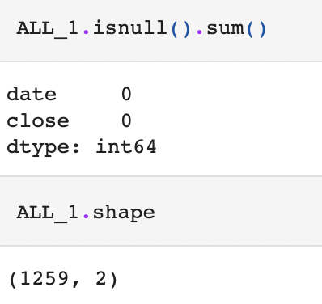

*Table 2: Used dataset and the Shape of Dataset*

Now, after data preparing, the data contains the 1259 historical close price (observations) and two variables: date and close price for AAL company.

* 1. *Visualization*

After data selecting and preparing, it shows the visualization of the historical close price for AAL company.

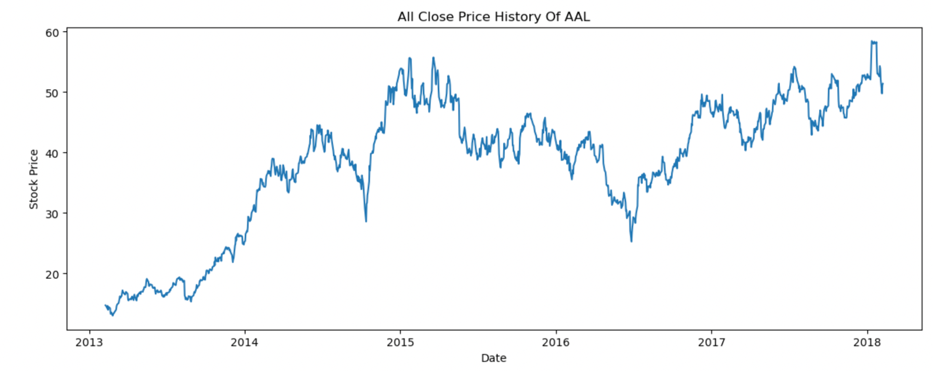

*Figure 1: Historical Close Price of AAL*

From this graph, we need to check for stationarity before applying the ARIMA model. If it non-stationary, we need to detrended and deseasonalized series to make data become stationarity.

* 1. *Check for Stationarity*

We decided to use the Augmented Dickey Fuller Test to test whether the series is stationary or not, since the ADF Test is one of a certain statistical test which is widely used for analyzing the stationarity of a series *(Prabhakaran, 2022).* In this test, the null hypothesis represents that the time series has a unit root, meaning this time series is non-stationary. It has some time dependent structure like trend and seasonality. While the alternative hypothesis suggests that the time series does not have a unit root, meaning this time series is stationary. It does not contain time dependent structures.

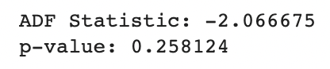

*Table 3: ADF Test Statistic*

The test statistics for ADF Test is -2.066675 and the p-value is 0.258124 which is greater than 0.05 significance level. This series fails to reject the null hypothesis at the 5% significance level. It is statistically insignificant to show that there is stationary at 5% significance level.

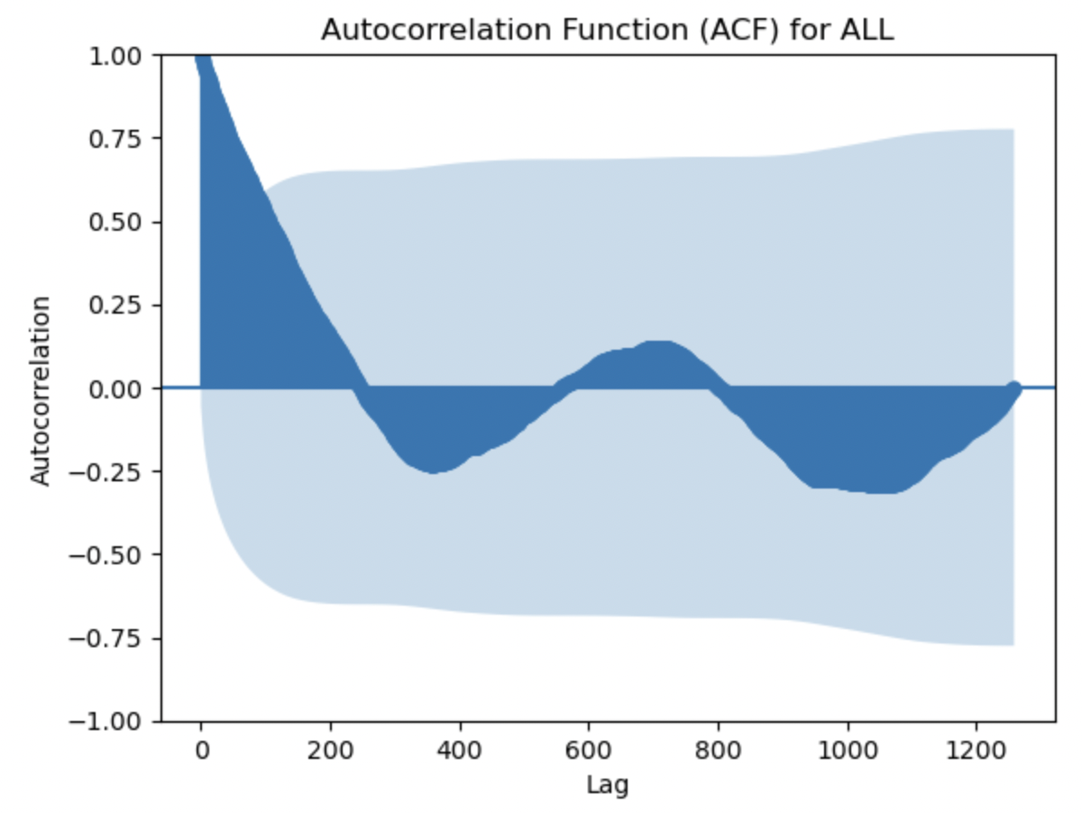

*Figure 2: The ACF for AAL*

From the graph, the autocorrelation function for ALL company contains the trend and seasonality. Hence, we need to remove such time dependent structures to make this series become stationary.

* 1. *Detrended and Deseasonalized Data*

Seasonal and Trend decomposition using Loess (STL) is a flexible and robust approach for decomposing time series data, while the Loess method is utilized to estimate nonlinear relationship *(Robert, 1990).* This project use STL method to remove trend and seasonality.

We noticed that there is seasonality in the data, and we take period equals to 10.

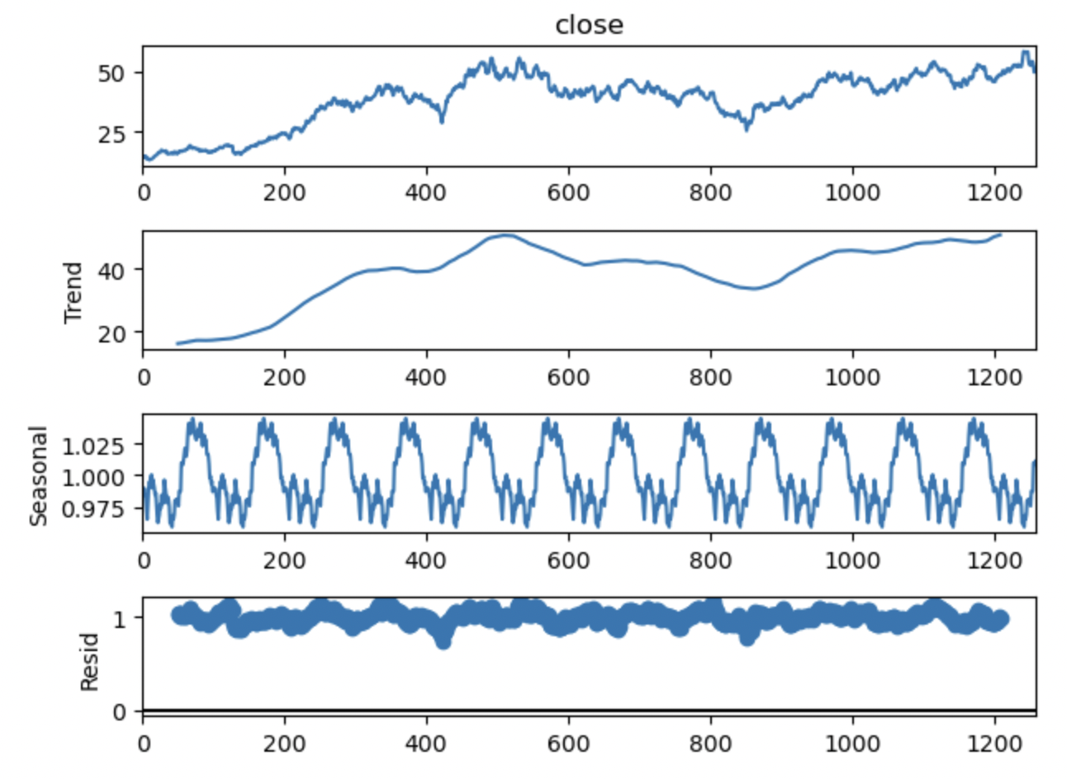

*Figure 3: STL Applied to the AAL company*

From the graph, the trend-cycle is more flexible, but the seasonal component remains constant throughout time. Then, we can use the STL method to decompose the trend and seasonality. When looking at time series data it is difficult to manually extract the trend or identify the seasonality. Fortunately, we can automatically decompose a time series and helps us have a clearer view of the components as it is easier to analyze the trend if we remove the seasonality and trend from our data and vice versa. Now, we visualize the detrended and deseasonalized data again:

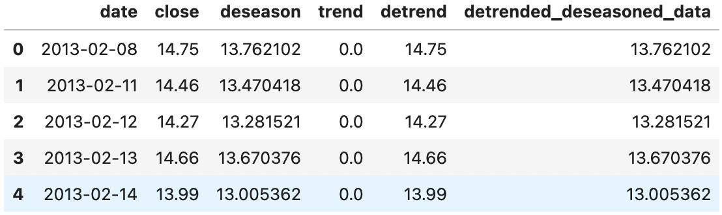

*Table 4: Dataset of Detrend and Deseason*

After deseasonalizing and detrending, it is harder to identify seasonality and trend directly from the figure. We are unable to completely remove seasonality and trend for the stock 'ALL'. Stock price seasonality is not a guaranteed or consistent phenomenon, and it can vary widely depending on various factors such as market conditions, global events, and company-specific factors.

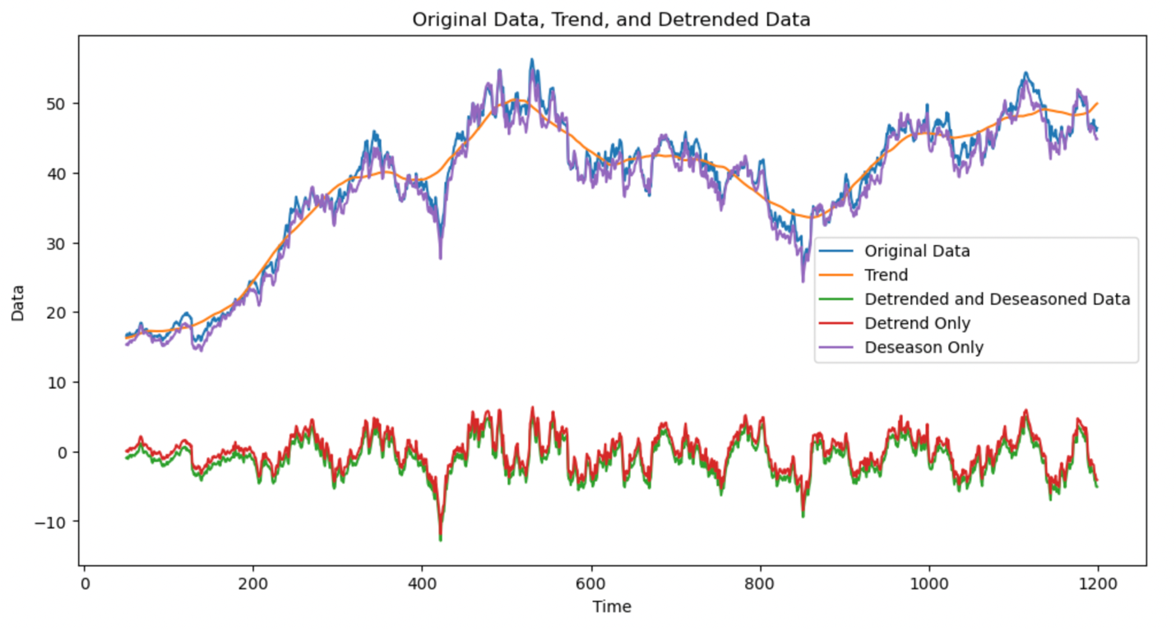

*Figure 4: Original, Detrend, and Deseaon Data*

However, by using graph, it is obvious that we almost remove the trend and seasonality. In order to avoid such time dependent structures, we will use ADF Test to test stationarity after finding the order of differencing.

1. **Time Series Model and Modeling Process**

Although we have Detrend only Data, Deseasoned only Data and Detrended and Deseasoned Data, we continued to use Deseasoned data to perform the modeling process. It is because that the deseasoned data works better with correct scale after trying different combinations.

* 1. *Autoregression 🡪 AR(p)*

AR represents a regression model that incorporates the dependent relationship between a current observation and observations over a previous period. The utilization of past values in the regression equation for the time series constitutes the AR(p) component (5-1). p is the order of the AR term, which denotes the number of lagged Y values to utilize as predictors. Hence, the function shown below (6-1):



Then we plot the actual and predicted close price of ALL company for AR(1) to show it performance:

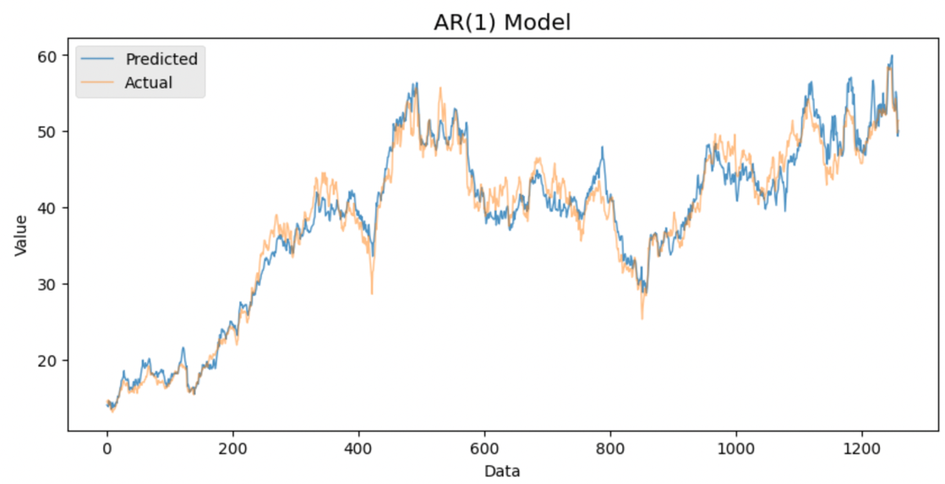

*Figure 5: AR(1) Model*

From the graph, we found that the predicted values almost fit the actual close price for AR(1) model. The reason is simple. The AR(1) model is particularly useful for predicting stock prices because it captures the persistence of trends in the stock market. That is, if a stock's price has been steadily increasing over the past few days, the AR(1) model assumes that the price is likely to continue increasing in the near future. On the other hand, if a stock's price has been declining, the model assumes that the price is likely to continue declining.

* 1. Moving Average 🡪 MA(q)

MA represents a regression model that incorporates the dependent relationship between a residual error obtained from a moving average model used to lagged observations. A moving average component represents the model's error as a combination of past error terms *(prashant, 2020).* q is the order of the MA term, which denotes the number of lagged forecast errors that are required to be included in the ARIMA model. Hence, the function shown below *(Prabhakaran, 2023):*



Then we plot the actual and predicted close price of ALL company for MA(1):

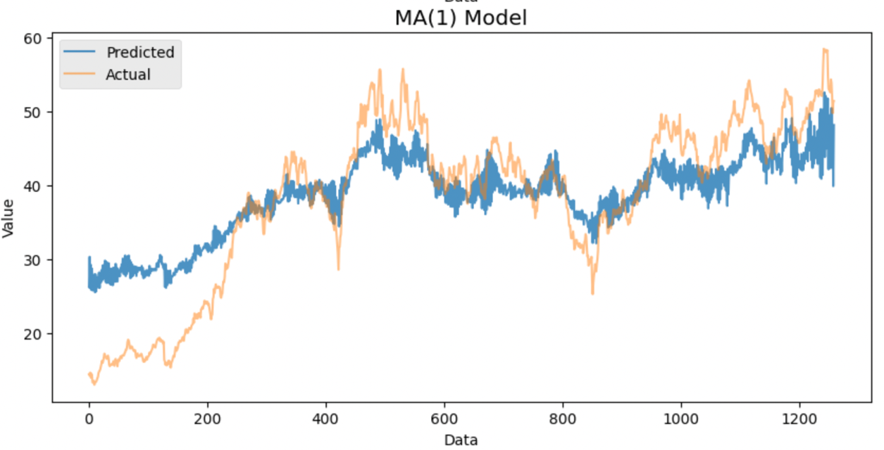

*Figure 6: MA(1) Model*

From the graph, we found that the predicted values do not fit the actual close price well for MA (1) model, which contains evident differences between two values. After the decomposing process, the MA model becomes non-invertible. A non-invertible MA model means that the past errors (or the innovations) of the model are dependent on future errors, which is theoretically impossible. In other words, if a model is non-invertible, it implies that the model's estimated coefficients may not be stable over time and that the model's forecast may not be reliable.

In summary, we use Root Mean Squared Error (RMSE) to test which model is better for forecasting. The lower the value of the RMSE, the better the model is.



*Table 4: RMSE for AR(1) and MA(1)*

The RMSE value also prove our conclusion that the AR(1) model performs well due to the smaller RMSE (2.2127).

* 1. *Autoregressive Integrated Moving Average 🡪 ARIMA (p, d, q)*

The ARIMA model involves differencing (d) the time series at least once to achieve stationarity and subsequently merging the AR and MA components. Integration (I) represents the differencing of observations which is the act of subtracting an observation from the observation at the preceding time step *(prashant, 2020).* The value of d is the minimum number of differencing which can make series become stationary. Hence, the function shown below *(Prabhakaran, 2023):*



Then we decided to use ACF and PACF (partial autocorrelation function) to find the order of differencing. In both ACF and PACF plots, the blue shading areas represents the significance thresholds, and the several vertical lines represent the ACF and PACF values. Only the vertical lines exceed the horizontal lines are considered significant. We only choose the significant terms, and the number of terms determines the order of model. We use PACF to determine the order used in the AR model. However, we use ACF to determine the order used in the MA model *(YouTube, 2019).*

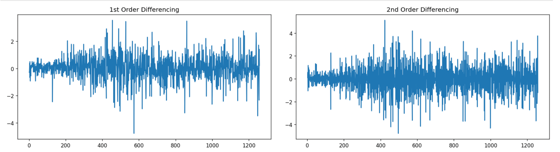

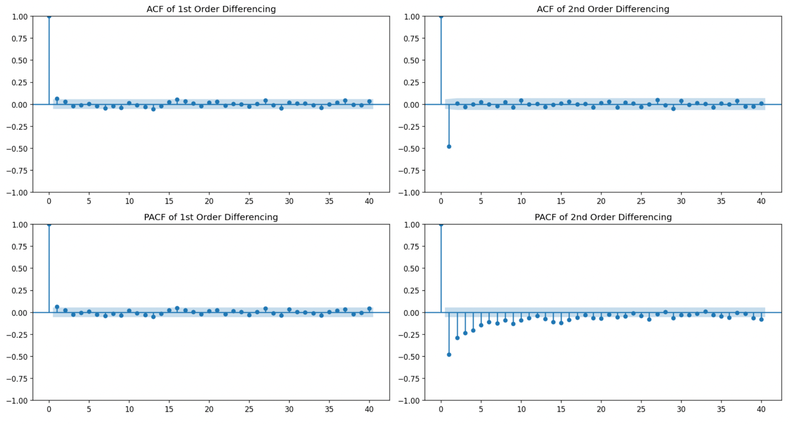

*Figure 7: ACF and PACF for 1st and 2nd Differencing*

From above plots, we can see that the time series reaches stationarity with one orders of differencing which is the minimum number of differencing. Then, we use the ADF Test again to test the stationarity for 1st order differencing.

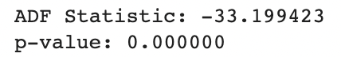

*Table 4: ADF Test Statistic*

The null and alternative hypothesis are same mentioned above. The test statistics for ADF Test is -33.199423 and the p-value is 0.00000 which is smaller than 0.05 significance level. This series rejects the null hypothesis at the 5% significance level. It is statistically significant to show that time series with 1st order differencing is stationary at 5% significance level.

After differencing, we can modify the non-invertible problem for MA model. Then, we randomly selected q and p based on the ACF and PACF plot with 1st order of differencing which is ARIMA (1,1,1).

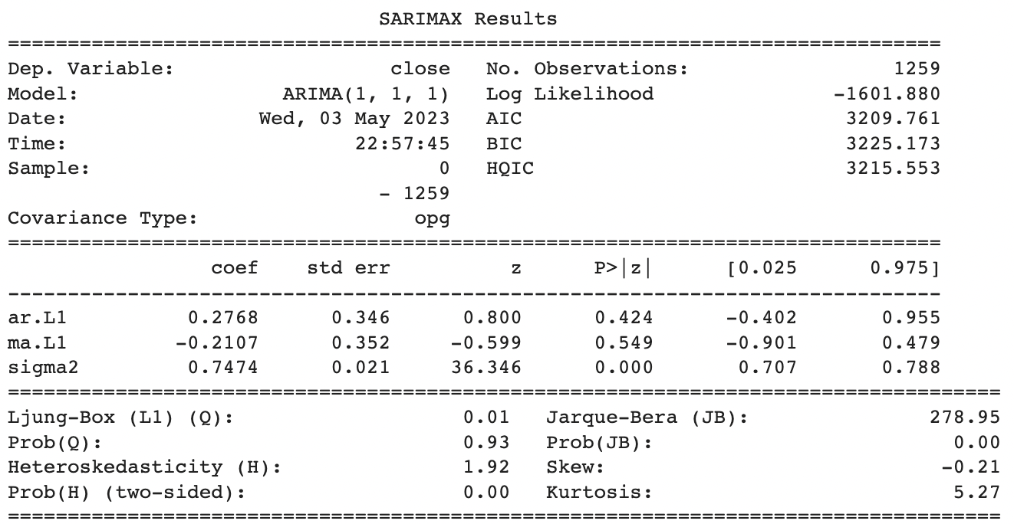

*Table 5: Summary for ARIMA (1, 1, 1)*

From this output, the null hypothesis represents that the orders p (or q) of AR (or MA) terms are not statistically significant, and the alternative hypothesis shows that the terms are statistically significant *(Minitab, 2023*). From the test statistic, the p-value for both p and q are greater than 0.05 significance level. It fails to reject the null hypothesis at the 5% significance level. It is statistically insignificant to show that the coefficients for both AR and MA are meaningful at 5% significance level. Therefore, we will do model validation to find which orders for AR and MA terms are statically significant in the next part.

Finally, in this part, we plot the residuals to make sure that there is constant mean and variance in ARIMA model.

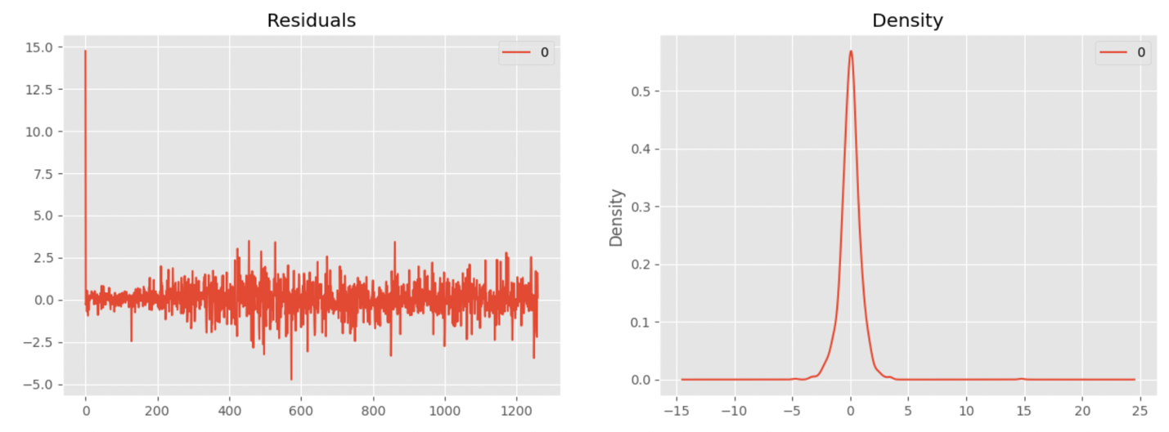

*Figure 8: Residuals Plot and Density of Residuals*

From graph, the residuals perform well due to near zero mean and uniform variance (normal distribution).

1. **Model Validation**

This project plans to use several methods to assess the performance of ARIMA model.

* 1. *Mean Square Error (MSE)*

The Mean Squared Error quantifies the proximity of a regression line to a group of data points. We preferred smaller MSE because it implies that the data points are tightly distributed around their central point, which is usually the mean *(Gupta, 2023).* In other words, smaller MSE represents the smaller error which generates the better estimators.

However, MSE is not a good method for model validation for ARIMA model. As q increases in the MA(q) model, the model becomes more flexible and able to capture more complex patterns in the data. This can result in a decrease in the MSE, as the model is better able to fit the data. However, as q continues to increase, the model may become overfit and start to capture noise rather than signal in the data. This can lead to an increase in the MSE. Thus, it is not meaningful for assessing the performance for AAL stock close price.

* 1. *Akaike Information Criterion (AIC) (Brownlee, 2020)*

AIC would be better than MSE in this project. AIC is a useful approach to select and evaluate model. The test statistic for AIC is formulated for logistic regression in the following equation:

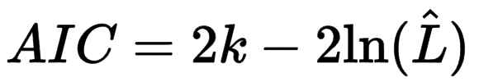

where k represents the number of estimated parameters in the model, and $\hat{L}$ shows the maximum value of the likelihood function for the model. The AIC statistic imposes a lower penalty on complex models, which can result in a greater emphasis on model performance on the training dataset and, consequently, lead to the selection of more intricate models. Thus, the model having the smallest AIC value is chosen.

* 1. *Bayesian Information Criterion (BIC) (Brownlee, 2020)*

BIC is relatively close to AIC. BIC is also common method to select and score model. The test statistic for AIC is formulated for logistic regression in the following equation:

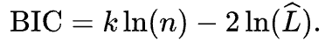

where k represents the number of estimated parameters in the model, and $\hat{L}$ shows the maximum value of the likelihood function for the model. The BIC penalty is stronger for complex models, resulting in larger scores, which reduces the likelihood of selecting more complex models. Thereby, the model having the smallest BIC value is chosen.

* 1. *Results*

First, we use loop to find the best order for both AR and MA. We found that the best p and q are both 5 after iterations which generate ARIMA (5, 1, 5).

Second, this project use auto ARIMA to choose p and q.

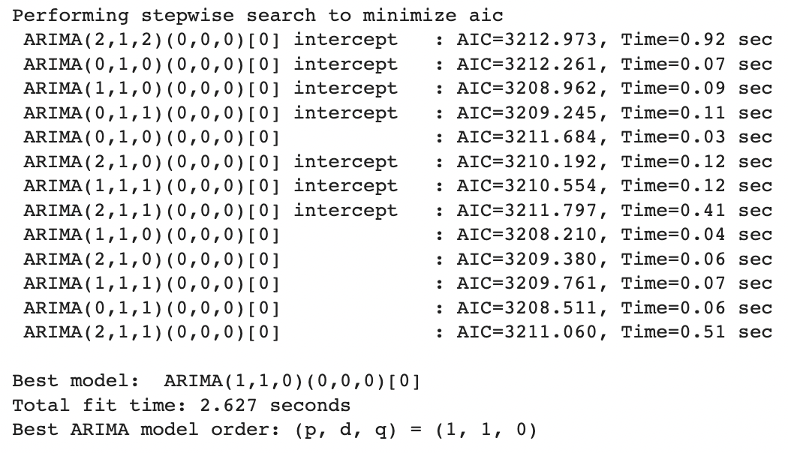

*Table 6: Best ARIMA Model by Using AIC*

From results, the best ARIMA model order is (1, 1, 0). The next step for us is to compare AIC and BIC for ARIMA (1, 1, 1) (according to the ACF and PACF plots), ARIMA (5, 1, 5) and ARIMA (1, 1, 0).

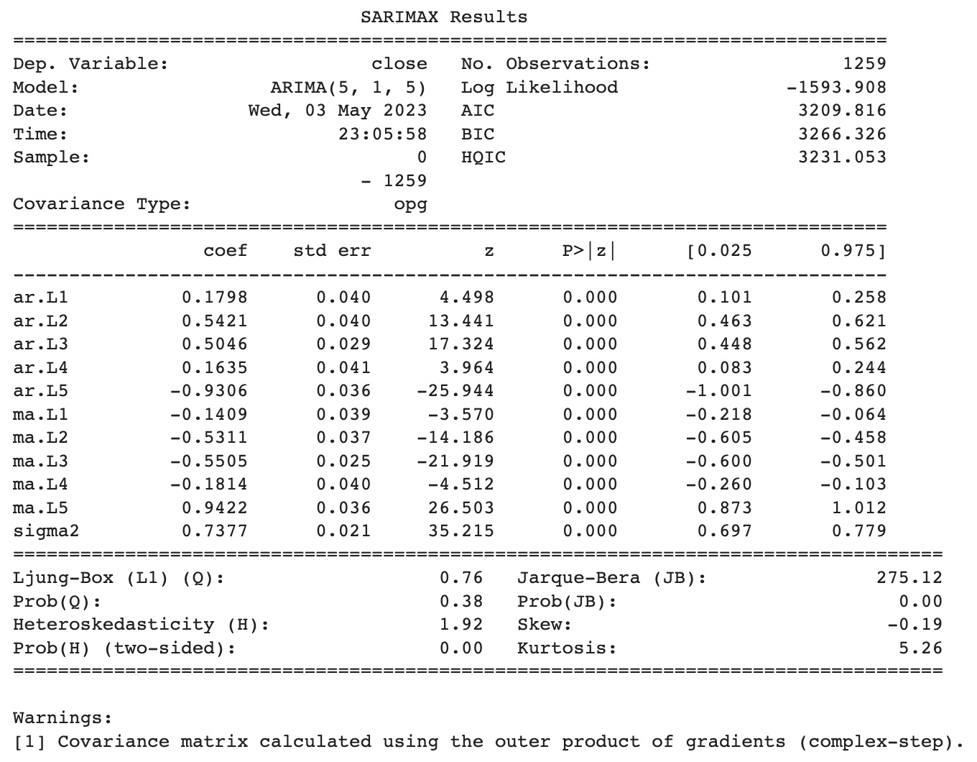

*Table 7: Summary for ARIMA (5, 1, 5)*

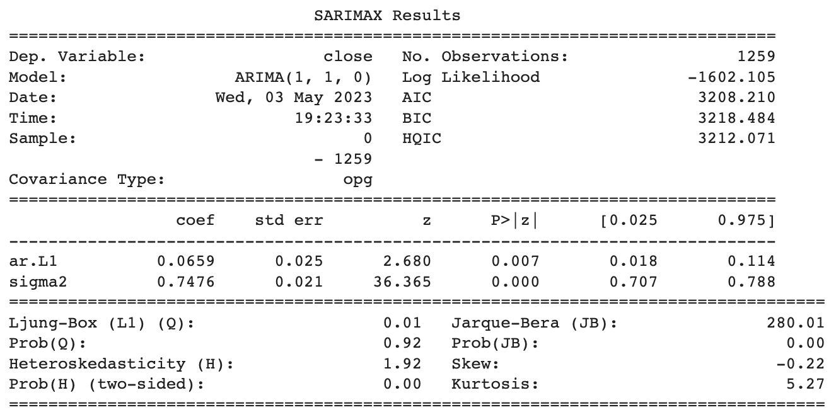

*Table 8: Summary for ARIMA (1, 1, 0)*

Compared to three summary outputs, ARIMA (1, 1, 0) has the minimum AIC and BIC values, which is 3208.210 and 3218.414 respectively. Thus, after model validation, we believe that the best ARIMA model order is (1, 1, 0).

1. **Forecasting**

For both forecasting, we split data into a training set and a testing set. We use 80% of observations for the training set and 20% of observation for the testing set.

* 1. *Forecasting by using ARIMA*

We first use ARIMA model to make predictions.

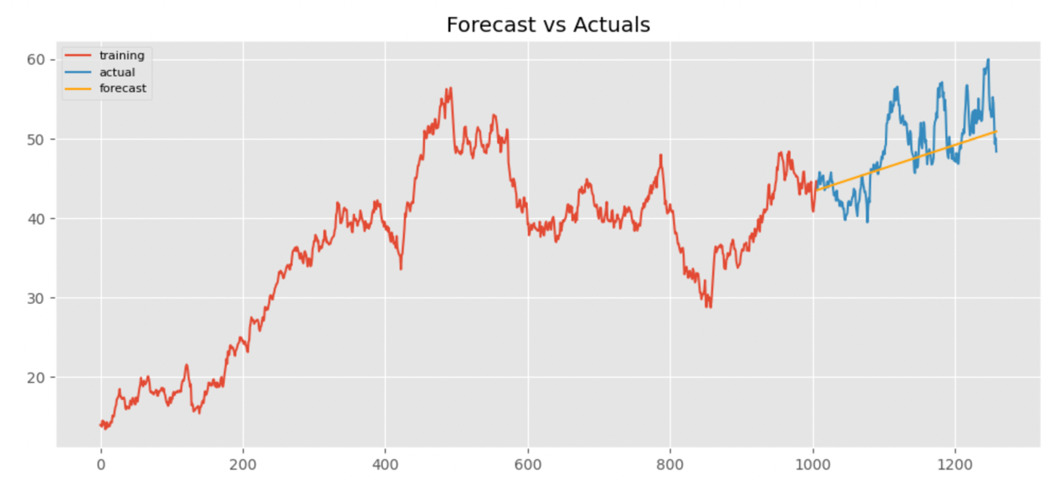

*Figure 9: Forecasting by using ARIMA (1, 1, 0)*

From the graph, the ARIMA (1, 1, 0) give us a directly forecast, and the actual value for close price is located between the 95% confidence thresholds. Also, the forecast value located the center of the actual close price value, generating an upward sloping tangent line for short term predictions.

However, this project focus on forecasting for AAL company in the stock market by using time series model. ARIMA model only forecast a short-term tendency for small dataset but not more accurate change in the long term. This is not helpful for investors for only short term and unclear forecast. We decided to improve these issues by applying LSTM

* 1. *Forecasting by using LSTM*

LSTM is one of the most effective models to predict time series if we need to solve huge amount of data. The LSTM cell enhances long-term memory even more effectively by enabling the learning of a larger number of parameters *(Keith, 2023).* Also, LSTM models are capable of making predictions about future values by analyzing sequential data from the past *(PredictHQ, 2023).* Moreover, the LSTM is adept at capturing the patterns of both long-term seasonality, such as yearly patterns, and short-term seasonality, such as weekly patterns. Therefore, LSTM is more suitable for forecasting close price time series of AAL company.

By using LSTM, there are certain hyperparameters that require tuning for the LSTM. model. We first scale and train our model by using MinMaxScaler. Then, we transfer the data inputs to be identified by TensorFlow.

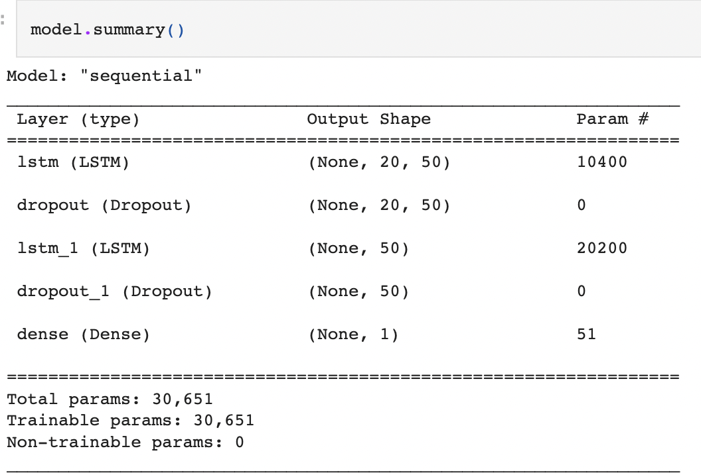

*Table 9: Summary for LSTM*

According to the summary, LSTM cells contains default activation function in this part which is tanh and recurrent activation function sigmoid. This contains two layers LSTM, and each LSTM layer contains 50 units. The dropout rate is 20%, which means that make 10 units becomes zero to prevent overfitting. Dense represents fully connected and returned to objective values to output one unit. We next train the LSTM model for 10 epochs and then make predictions. Hence, we can plot the actual and predicted stock close price of AAL company by using LSTM model.

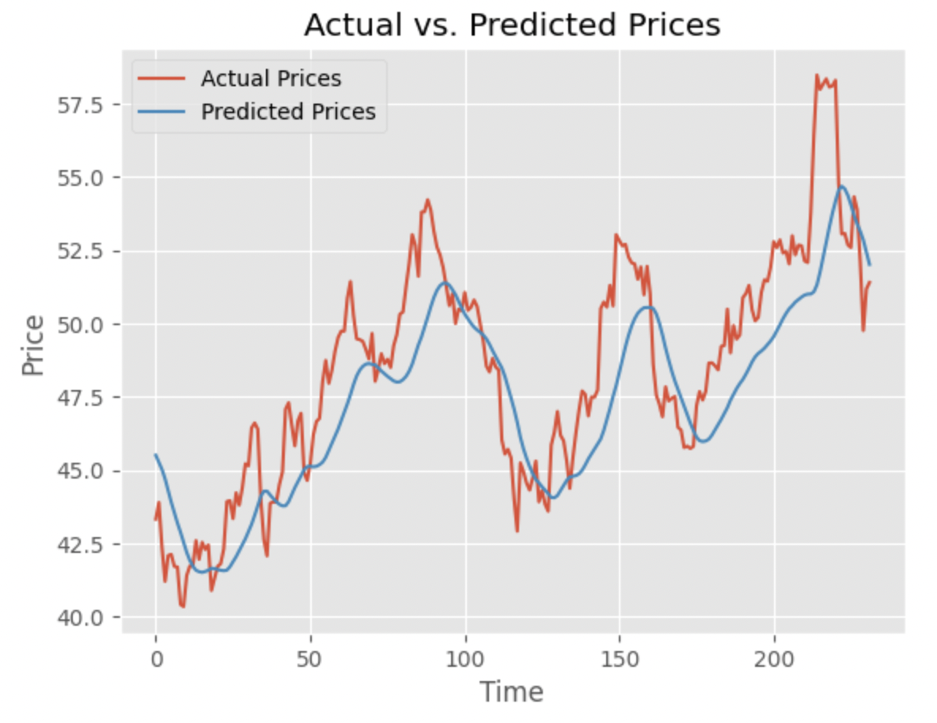

*Figure 10: Forecasting by using LSTM*

From the graph, it shows the successive prediction for both short term and long term for AAL stock close price. The prediction almost has the same tendency compared to the actual values. It is clearly to show that LSTM has a better performance than ARIMA model. Thus, LSTM model could offer a greater accuracy for AAL close price prediction which results in better decision making for the investors.

1. **Conclusion**

In conclusion, our project talks about market prediction for stock close price using ARIMA model and improving by using LSTM model for American Airline Group Inc. (AAL). We check the stationarity for this dataset by using ADF Test. Then, we use deseaon data to perform the ARIMA data to find the 1st order differencing can make dataset become stationary. For the model validation, we use AIC and BIC to find the best ARIMA order is (1, 1, 0). The last part is forecasting. Although ARIMA can make short term trend for prediction, we improve our prediction model to make better forecasting by using LSTM model. It is obvious that LSTM depicts a more accurate prediction for close price of AAL company, which can offer a guide for investors to make informed decisions in stock market.

There are two possible extensions for this project in the future. First, this dataset only contains through 2013 to 2018. However, there are several external impacts to affect the stock price in the stock market such as Covid-19 pandemic. The current project does not have ability to simulate and forecast such external impacts. If we use data through 2018 to 2023 of AAL stock close price, it might generate a different result for this project. Second, we also can apply the back testing to make better prediction for such extreme external impacts. It is because that back testing enables investors to test their trading strategies using historical data to evaluate their effectiveness, measure risk, and assess profitability without the need to risk actual capital *(Chen, 2022).* Third, we can continue to improve LSTM model to evaluate our data and forecast more accurate predictions by tuning hyperparameters. The suggestion is to add more LSTM layers and increase the number of epochs or batch size to observe the effect on the accuracy results *(Nandu, 2019).* Hence, such extensions are helpful to improve the accuracy for this project, and also can help investors to avoid risks and maximize their profits. If given more time, we may conduct more detailed research on this project which might gain more accurate results than this project.

**Reference:**

Pathak, P. (2022, July 27). Stock market price trend prediction using time series forecasting. Analytics Vidhya. Retrieved May 4, 2023, from <https://www.analyticsvidhya.com/blog/2020/11/stock-market-price-trend-prediction-using-time-series-forecasting/>

Prabhakaran, S. (2022, April 4). Augmented dickey-fuller (ADF) test - must read guide - ml+. Machine Learning Plus. Retrieved May 4, 2023, from <https://www.machinelearningplus.com/time-series/augmented-dickey-fuller-test/>

Cleveland, R. B., Cleveland, W. S., McRae, J. E., & Terpenning, I. J. (1990). STL: A seasonal-trend decomposition procedure based on loess. *Journal of Official Statistics*, *6*(1), 3–33. <http://bit.ly/stl1990>

Prashant. (2020, October 23). Arima model for time series forecasting. Kaggle. Retrieved May 4, 2023, from <https://www.kaggle.com/code/prashant111/arima-model-for-time-series-forecasting>

Prabhakaran, S. (2023, May 4). Arima model - complete guide to time series forecasting in python: ML+. Machine Learning Plus. Retrieved May 4, 2023, from <https://www.machinelearningplus.com/time-series/arima-model-time-series-forecasting-python/>

YouTube. (2019, May 5). Autocorrelation function (ACF) vs. Partial Autocorrelation Function (PACF) in time series analysis. YouTube. Retrieved May 4, 2023, from <https://www.youtube.com/watch?v=5Q5p6eVM7zM>

Interpret the key results for analyze factorial design. Minitab. (n.d.). Retrieved May 4, 2023, from <https://support.minitab.com/en-us/minitab/21/help-and-how-to/statistical-modeling/doe/how-to/factorial/analyze-factorial-design/interpret-the-results/key-results/>

Gupta, A. (2023, February 14). Mean squared error: Overview, examples, concepts and more: Simplilearn. Simplilearn.com. Retrieved May 4, 2023, from <https://www.simplilearn.com/tutorials/statistics-tutorial/mean-squared-error?source=sl_frs_nav_playlist_video_clicked>

Brownlee, J. (2020, August 27). Probabilistic model selection with AIC, BIC, and MDL. MachineLearningMastery.com. Retrieved May 4, 2023, from <https://machinelearningmastery.com/probabilistic-model-selection-measures/>

Keith, M. (2023, March 30). Exploring the LSTM neural network model for Time Series. Medium. Retrieved May 4, 2023, from <https://towardsdatascience.com/exploring-the-lstm-neural-network-model-for-time-series-8b7685aa8cf>

The value of LSTM in time series forecasting. PredictHQ. (n.d.). Retrieved May 4, 2023, from <https://www.predicthq.com/events/lstm-time-series-forecasting>

Chen, J. (2022, October 10). Backtesting: Definition, how it works, and downsides. Investopedia. Retrieved May 4, 2023, from <https://www.investopedia.com/terms/b/backtesting.asp>

Nandu, matam. (2019, December 1). How do I increase accuracy with keras using LSTM. Cross Validated. Retrieved May 4, 2023, from https://stats.stackexchange.com/questions/336592/how-do-i-increase-accuracy-with-keras-using-lstm

**Data Sources**

Nugent, C. (2018, February 10). S&P 500 stock data. Kaggle. Retrieved May 4, 2023, from <https://www.kaggle.com/datasets/camnugent/sandp500>

The original dataset shown in the same zip file for final project.

**Code used for the analysis of the data**

All codes are shown as html and ipynb in the same zip file for final project. The used results are shown in the project by screen shots.